### SYNOPSIS

**Title**

**“Smart Canteen”**

### MCA113-MINI PROJECT

By

“Piyush Kulbhushan Adake”

“3123015010194”

# Mini Project work carried out at

## Faculty of Commerce and Management



**VISHWAKARMA UNIVERSITY**

**PUNE**

September 2023

Project progress Summary:

|  |  |  |  |  |
| --- | --- | --- | --- | --- |
| Sr. No | Description of Work | Start Date | End Date | Status |
| 1 | Study | 22/09/2023 | 25/009/2023 | Completed |
| 2 | Design | 26/09/2023 | 07/10/2023 | Completed |
| 3 | Development | 10/10/2023 | 10/11/2023 | Completed |
| 4 | Testing | 11/11/2023 | 25/11/2023 | In-Process |
| 5 | Documentation | 26/11/2023 | 31/11/2023 | Uncompleted |

* **Study-**

Studded the Project in depth. Calculate the Require time To build the Project.

This project was undertaken with the objective of enhancing accessibility and convenience for students and staff to order meals, access menus, and manage their accounts seamlessly. Studded the User Requirements as well as Admin Requirements. Studded the How flow is working To build the project. Choose the Required Platform for development. As well as choose Required and Suitable Environment(JAVA ENVIRONMENT) For Project.

* **Design-**

The architectural design of the Smart Canteen Website, developed primarily in Java, focused on a layered approach to ensure scalability, maintainability, and extensibility. The system comprised three main layers: the presentation layer, business logic layer, and data access layer. The presentation layer, built using JavaServer Pages (JSP) and Servlets, facilitated the user interface and interaction with end-users.

**Draw the Design for Better Understanding.**

**Draw the Data Flow Diagrams.**

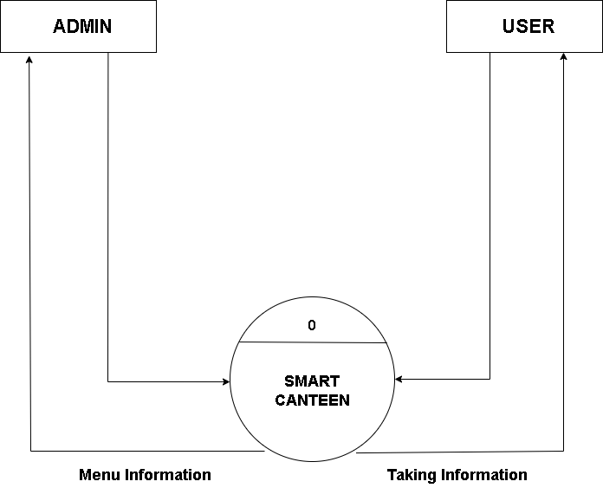

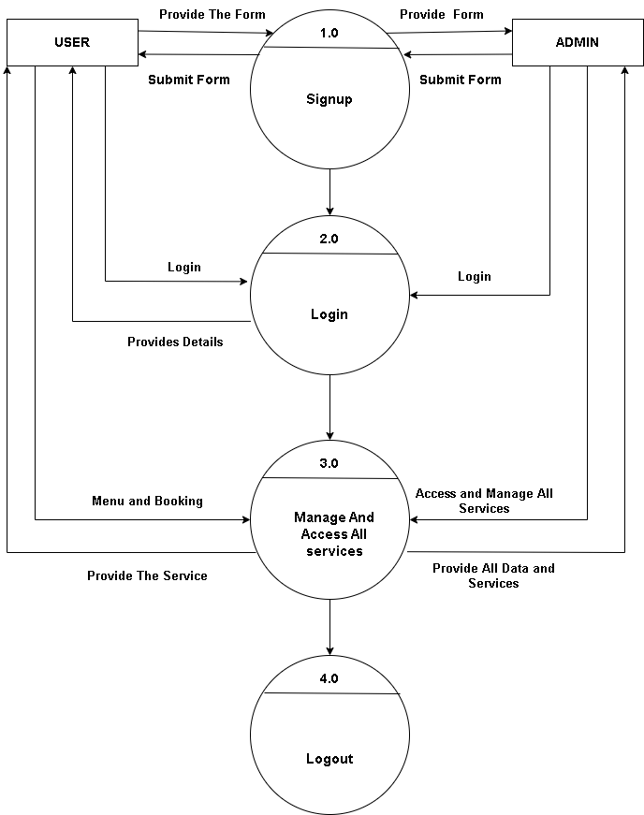

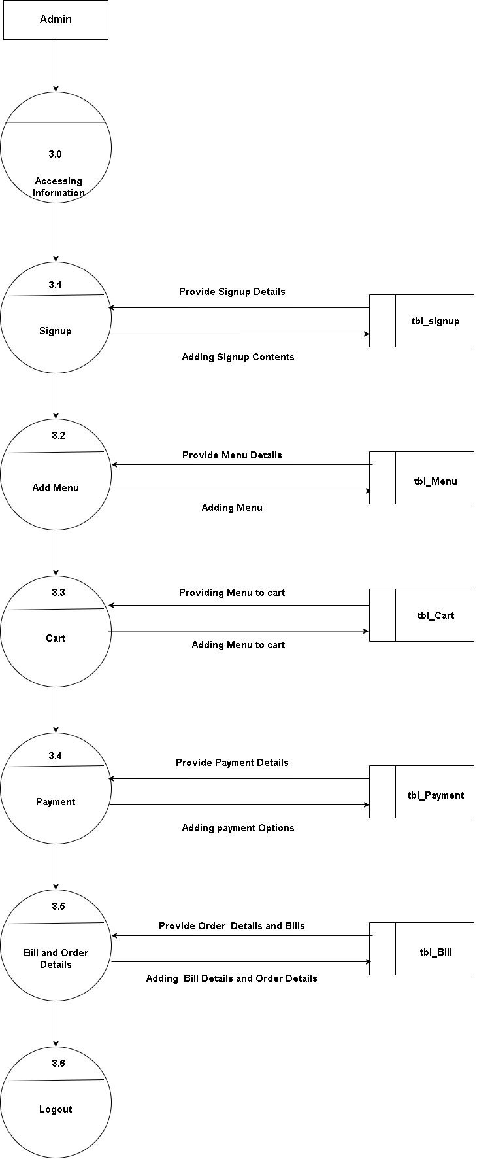

**Draw the Entity Relationship Diagram.**

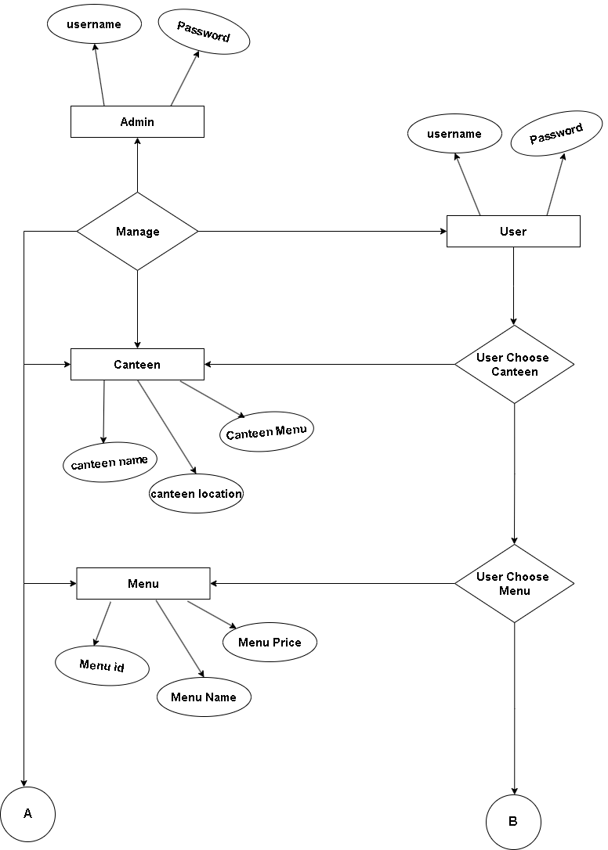

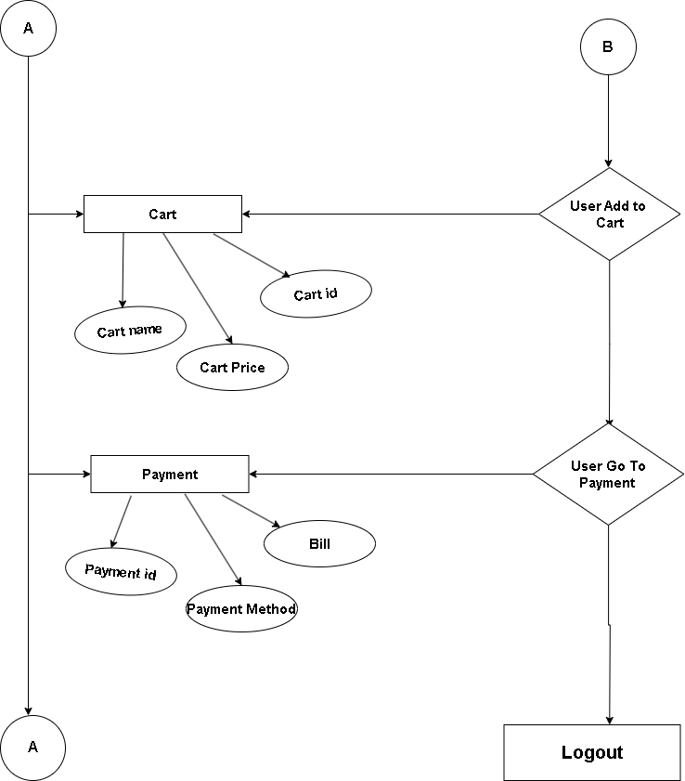

**Draw the Sample of Database Design for Better Understanding of Database Design. And flow of Database.**

**1. Customers:** Information about the customers who visit the canteen.

**2. Menu Items:** Details about the food and beverages available in the canteen.

**3. Orders:** Information about the orders placed by customers.

**4. Employees:** Details about the canteen staff, such as chefs, waiters, etc.

**5. Suppliers:** Information about the suppliers who provide ingredients and other supplies to the canteen.

**6. Transactions:** Records of financial transactions, such as payments and invoices.

* Customers (customer_id, name, contact_info, loyalty_points, ...)
* Menu_Items (item_id, name, description, price, ingredients, ...)
* Orders (order_id, customer_id, order_date, total_amount, ...)
* Employees (employee_id, name, position, contact_info, shift_details, ...)
* Suppliers (supplier_id, name, contact_info, delivery_schedule, ...)
* Transactions (transaction_id, order_id, payment_method, amount, ...)

Using the all the Design we plan the Flow of Our project. Its help for Development Phase.

* **Development-**

After the Design Phase Completed I Started the Actual Development phase of project. Using the Netbeans IDE and MySql Workbench I started the Fronted Jsp pages According to the Project. Simultaneously I crate the Database. First I develop the admin panel with the help of Design. After the completion of admin panel pages I connect the database using the servlet pages and my-sqlConnector.jar Library . after adding the data I retrieve the data to in user pages such like Menu name, menu photo, menu description and price.

* **Testing-**

After the Development phase I start the Testing phase. In testing Phase I check the Validation Work as well as All Database Queries.

I also Check the The Admin side data flow . The Testing Phase Is Still in Process.

The User Side Dataflow and Validation testing is Going on .

* **Documentation -**

The Documentation Phase is Uncompleted . After Testing phase I complete the Documentation Phase.